**Development Environment Setup Guide**

**Selecting and Installing your Operating System (OS)**

~ Select an Operating System that best suits your machine and the projects an program that you want to install in your machine.

~ You can visit this website to download your preferred OS if its Windows: <https://www.microsoft.com/en-gb/software-download/> and the Other OS such as Linux and Ubuntu and so on can be downloaded by visiting your favorite browser and Prompt-searching “Your-OS name” download on the browser in order to download it.

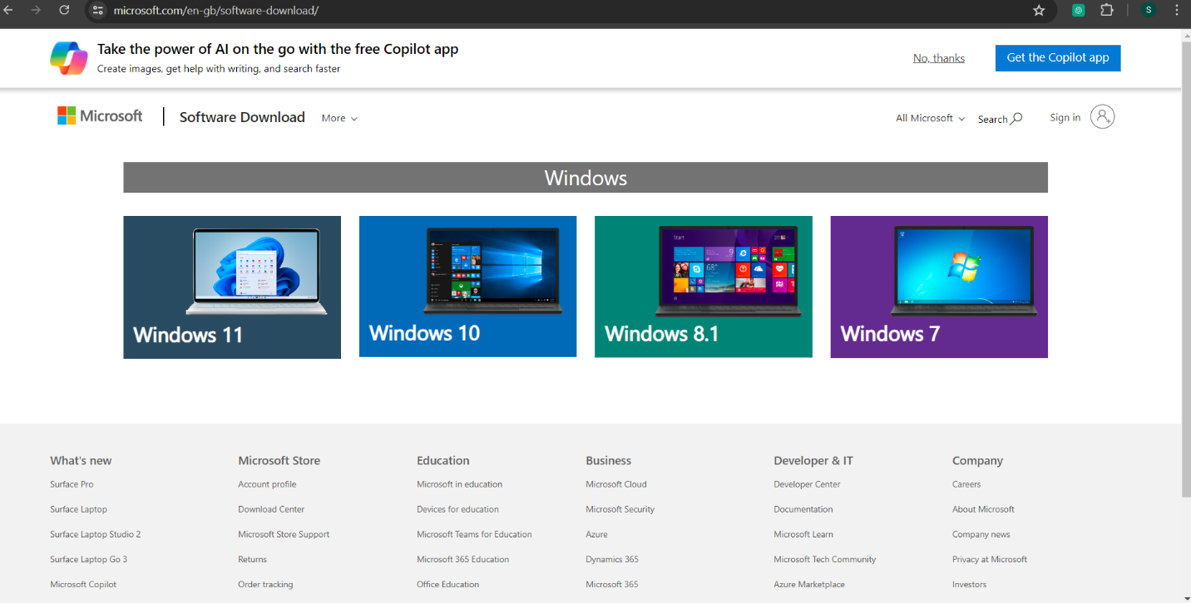

~ For my case am using Windows 10 since it is compatible with my machine.

~ Follow the step-by-step guide given by the OS you chose to download during its installion and you will have successfully downloaded and installed it.

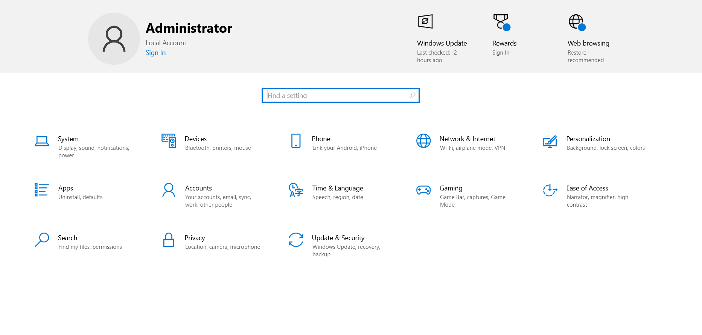

**Installing Visual Studio Code**

**Step-by-Step Instructions:**

1. Go to the Visual Studio Code download page: <https://code.visualstudio.com/download> .

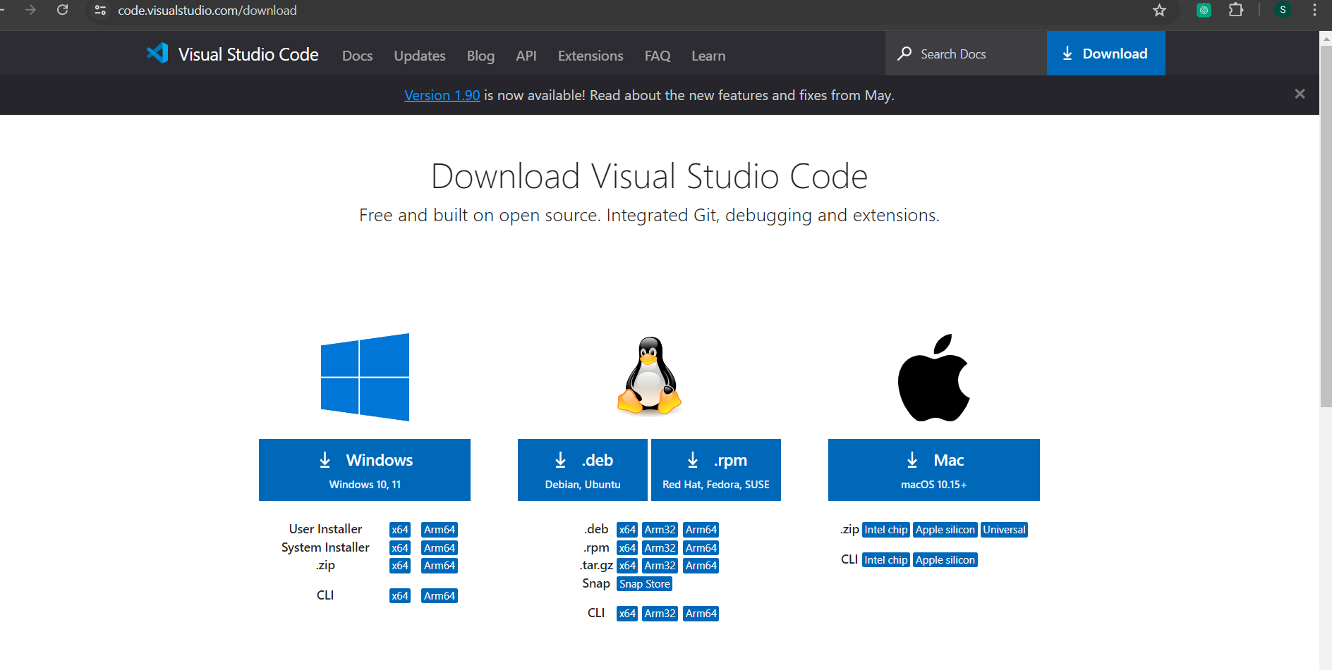

2. Choose the appropriate version for Windows or your preferred OS and download the installer.

3. Access the Downloads on your file explorer after the Visual Studio Code has finished downloading and open it.

4. Run the installer and follow the on-screen instructions to install Visual Studio Code.

5. After complete installation, You can open the Visual Studio Code where it will guide you on what to do, download and install as well as contents present in the visual Studio code that will help with the smooth running of the program.

~ Below is my fully installed and functioning Visual Studio Code.

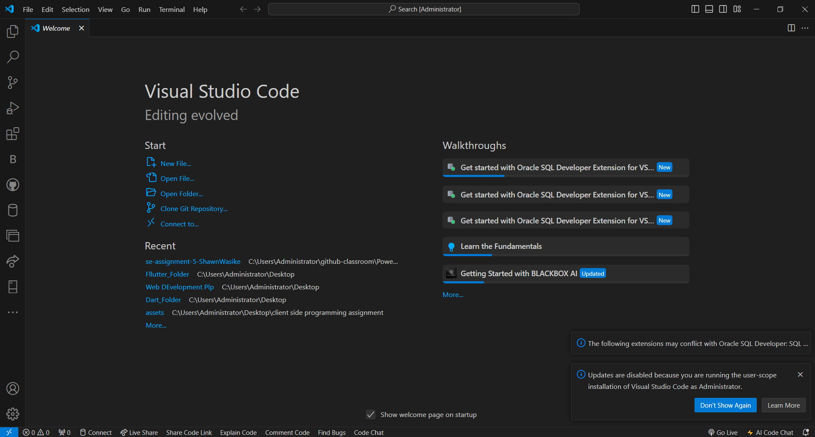

**Setting Up Git and GitHub**

**Install Git**

**Step-by-Step Instructions:**

1. Go to the Git download page: <https://www.git-scm.com/downloads> .

2. Select git version you want to install and and on which OS you want to run it on(Windows, Linux, MacOS)

3. Download the Latest version installer and run it.

4. Follow the on-screen instructions to install Git with the default settings.

5. After full installation Git Bash, Git GUI and Git CMD will all be fully installed.

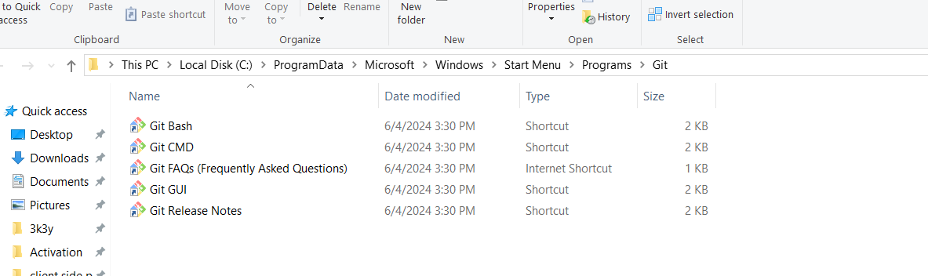

**Configure Git**

**Step-by-Step Instructions:**

1. Open Git Bash.

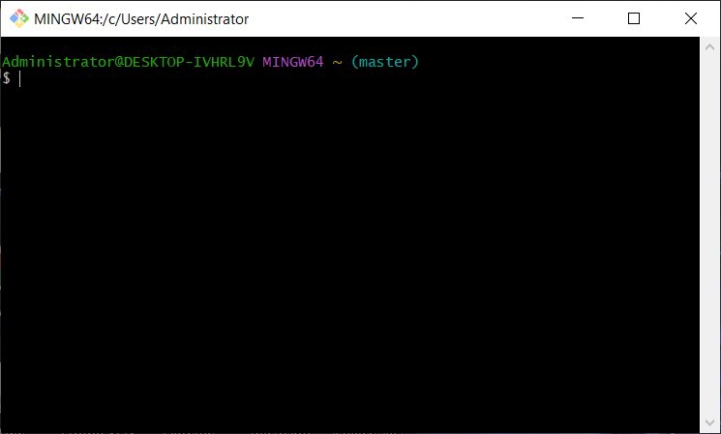

2. Set your username and email if its’ your first time using Git Bash using the commands below:

[git config --global user.name "Your Name"]

[git config --global user.email [youremail@example.com](mailto:youremail@example.com)]

3. After it is fully set up and linked to your GitHub using similar email and name as listed (in step 2) above you will able able to use it effectively.

**Create a GitHub Account**

**Step-by-Step Instructions:**

1. Go to GitHub on your preferred browser: <https://github.com/> .

2. Click on "Sign up" and follow the instructions to create a new account.

3. Fill in your details while signing up and create a strong but rememberable password.

4.After signing up you can create your GitHub profile and new respitories and projects and post them there.

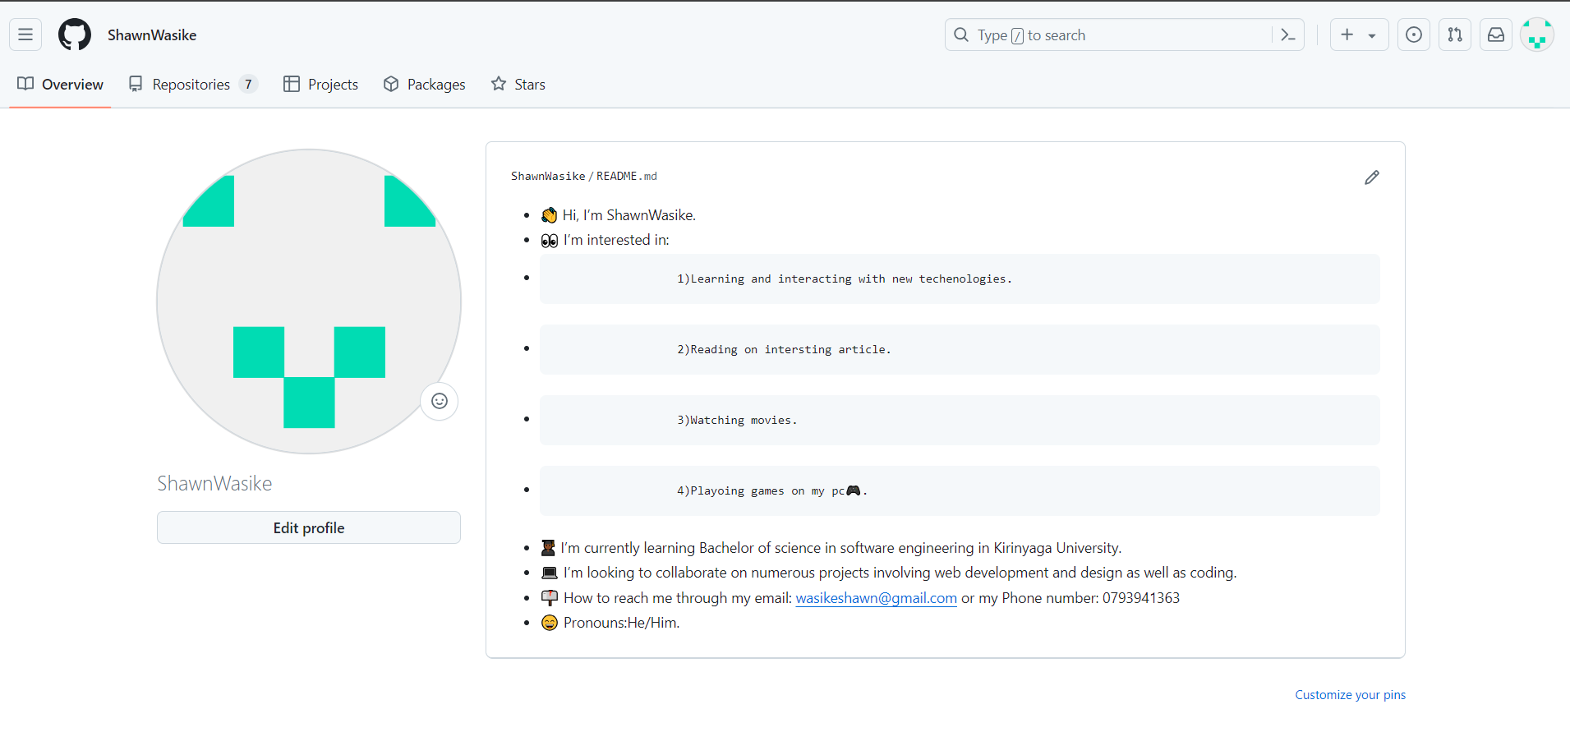

5. You’ll have an onscreen guide and instructions of how to use your GitHub account and all its operations and functionality.

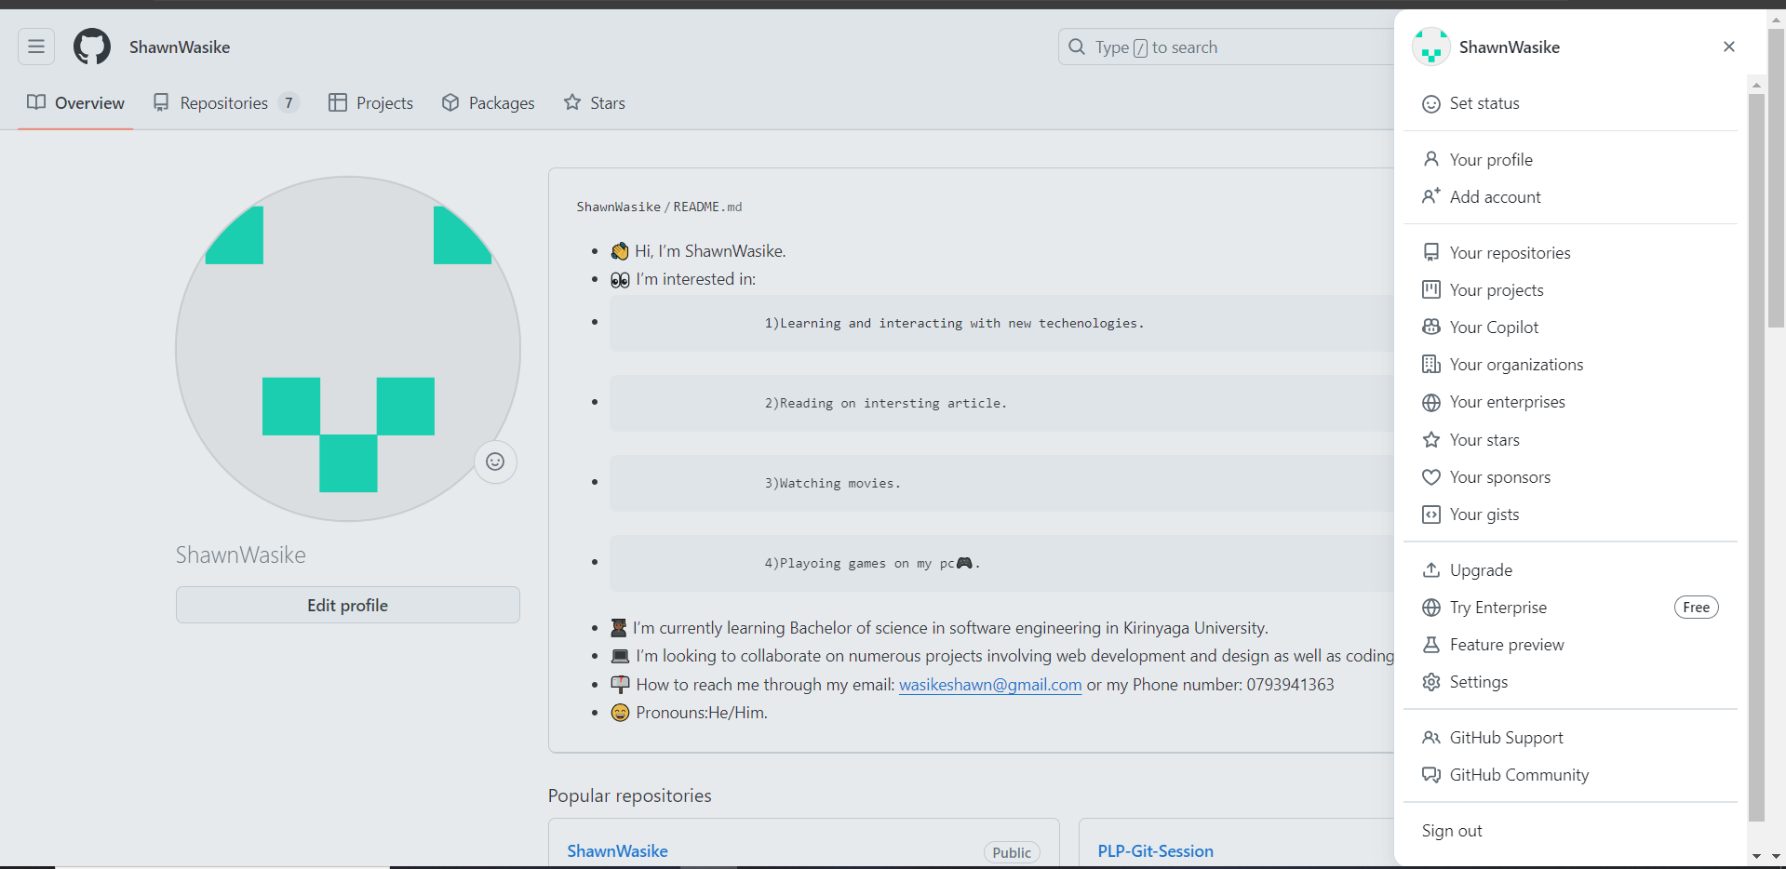

**Initialize a Git Repository**

**Step-by-Step Instructions:**

1. Open your Git Bash.

2. It will open a command line terminal similar to that of Windows Powershell and Command Line of windows .

3. Navigate to your project directory and initialize a Git repository:

~ On Git Bash:

[ mkdir GitPLPSession ]

[ cd GitPLPSession ]

[ git init ]

**Make Your First Commit**

**Step-by-Step Instructions:**

~ Here is an example of how make your first commit:

1. Create a README file:

~On Git Bash:

[ echo "# GitPLPSession " >> README.md ]

2. Add and commit the file:

~ On Git Bash:

[ git add README.md ]

[ git commit -m "Initial commit" ]

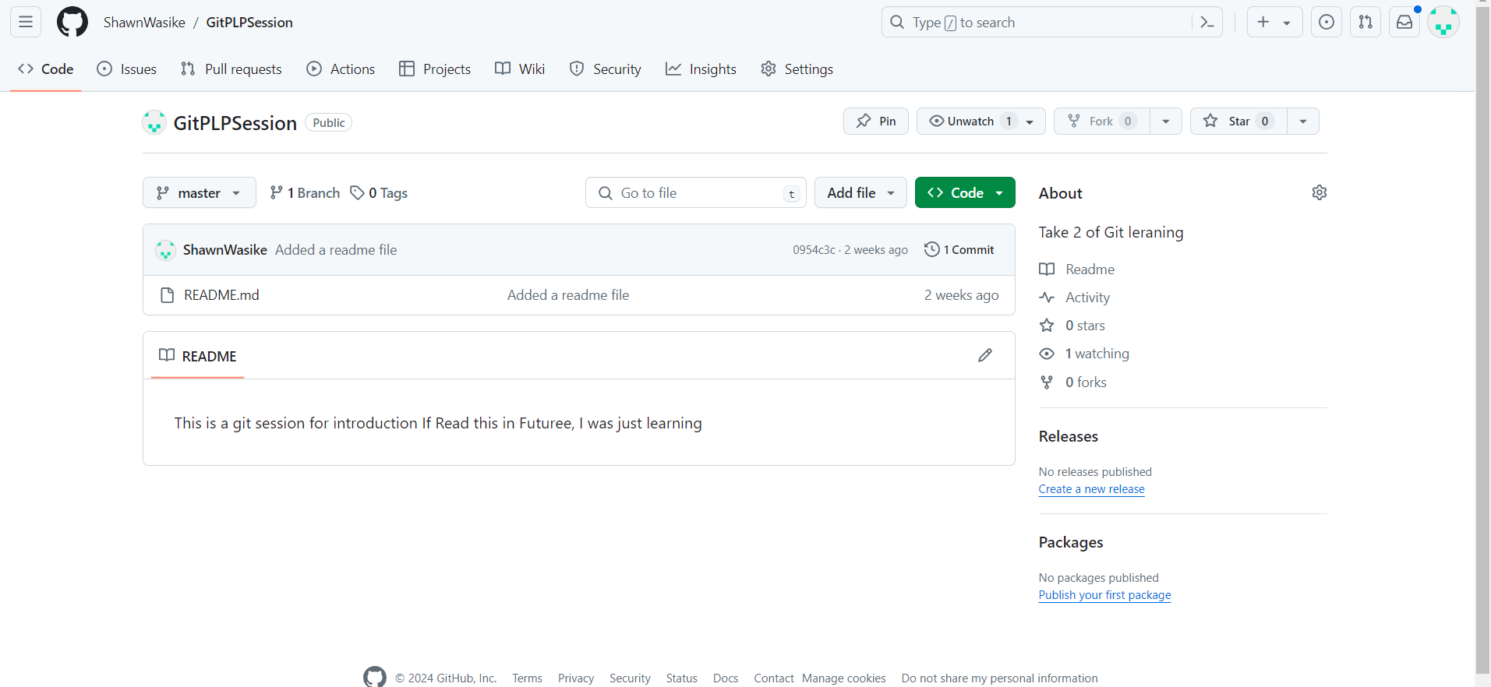

**Installing Python**

**Step-by-Step Instructions:**

1. Go to the official Python download page: <https://www.python.org/> .

2. Download the installer for the latest version of Python for Windows.

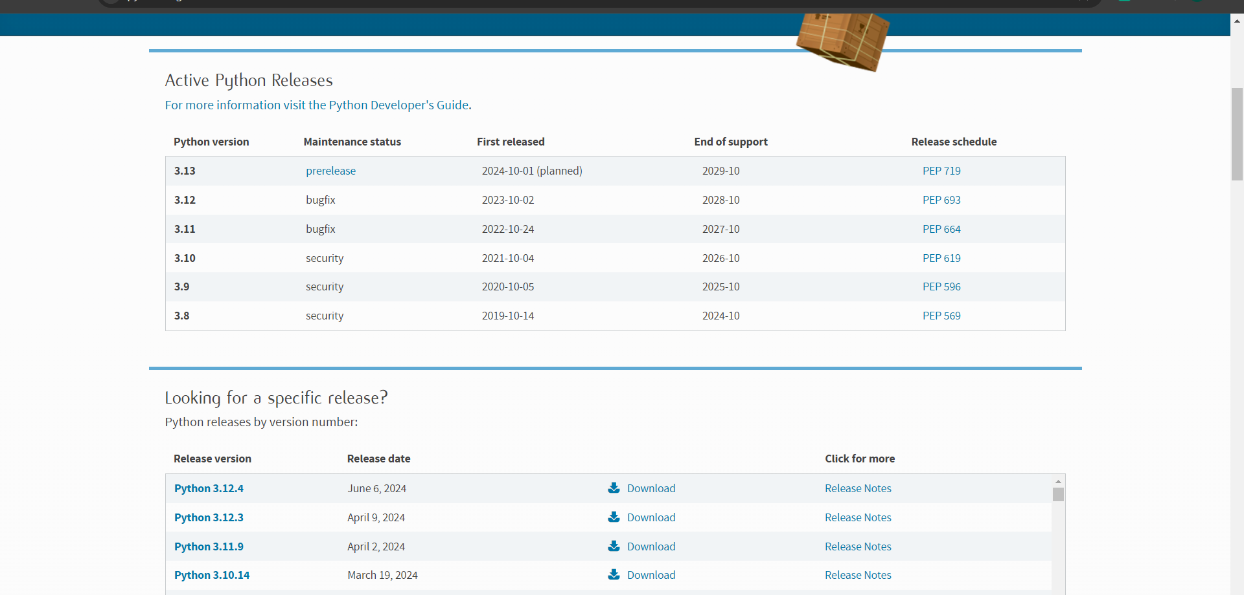

3. Select the most suitable and latest version befitting your machine specifications.

4. Run the installer and make sure to check the box "Add Python to PATH."

5. Follow the on-screen instructions to complete the installation.

6. You’ll have completely installed the python and can confirm if its successfully installed by typing:

[ python –version]

On your Git Bash, it will show the type of python successfully installed in your machine.

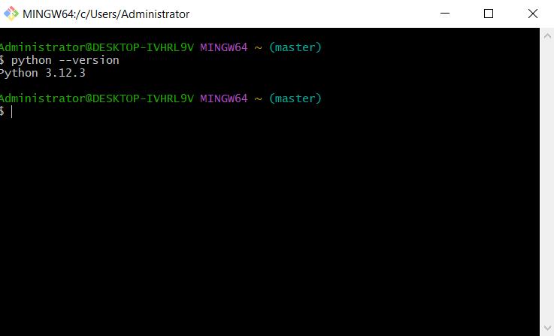

**Installing pip**

**Note:** Pip is included with Python 3.4 and later.

~ However If it is not installed we can install it using our Git Bash:

**Step-by-Step Instructions:**

1. Open Git Bash.

2. Type in the command:

[ winget install pip].

~ To Successfully install it.

2. Verify the installation of pip:

~ On Git Bash Type:

[ pip –version ]

~ To verify if Pip is successfully installed.

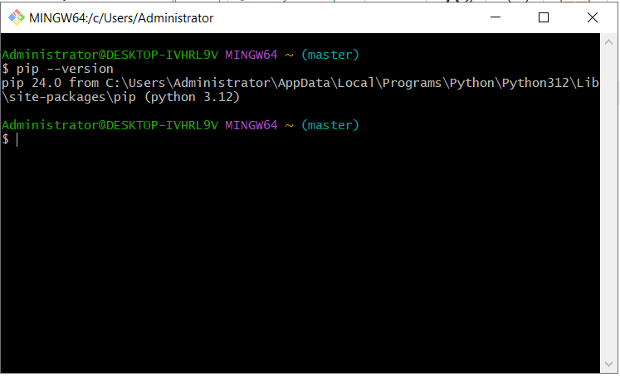

**Configuring MySQL**

**Step-by-Step Instructions:**

1. Go to the MySQL download page: <https://dev.mysql.com/downloads/installer/> .

2. Download the MySQL Installer.

3. Run the installer and follow the on-screen instructions to install MySQL Server and MySQL Workbench.

4. Configure MySQL Server with a root password and other settings as needed and guided by the onscreen instructions during installation.

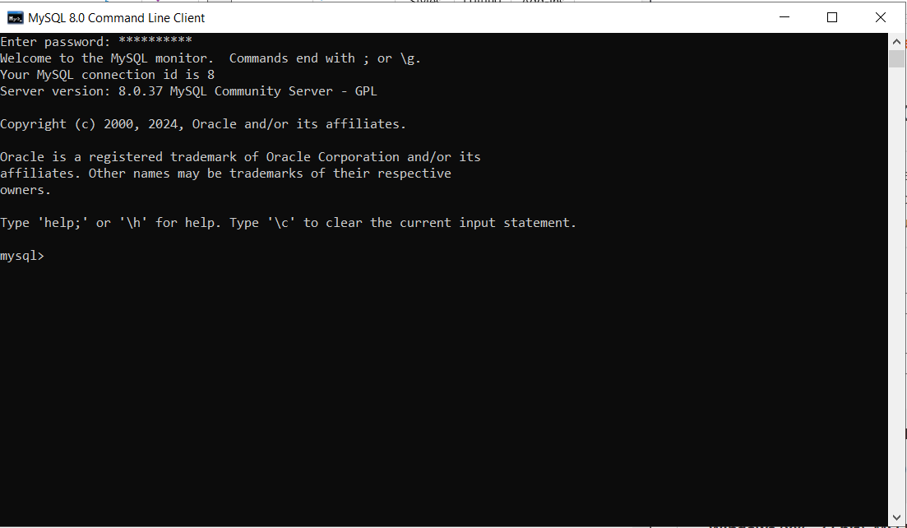

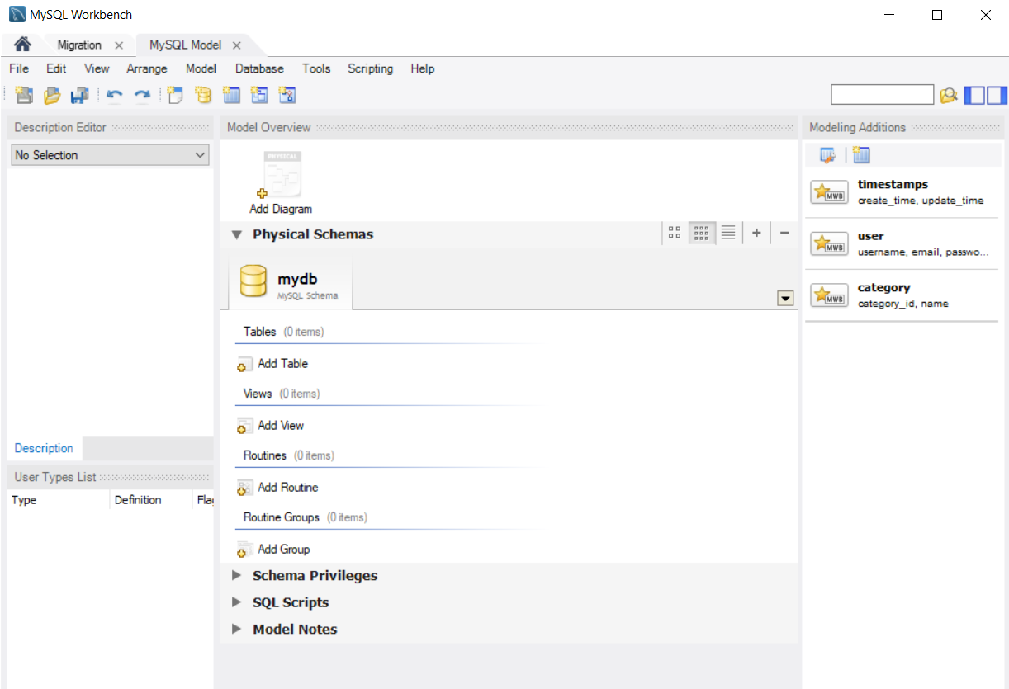

**Exploring VS Code Extensions**

~ At first you’ll need to download Visual Studio Code Compatible with you machine at its download site: <https://code.visualstudio.com/download> .

**Step-by-Step Instructions:**

1. Open Visual Studio Code.

2. Go to the Extensions view by clicking on the Extensions icon in the Activity Bar on the side of the window or press `Ctrl+ Shift+ X`.

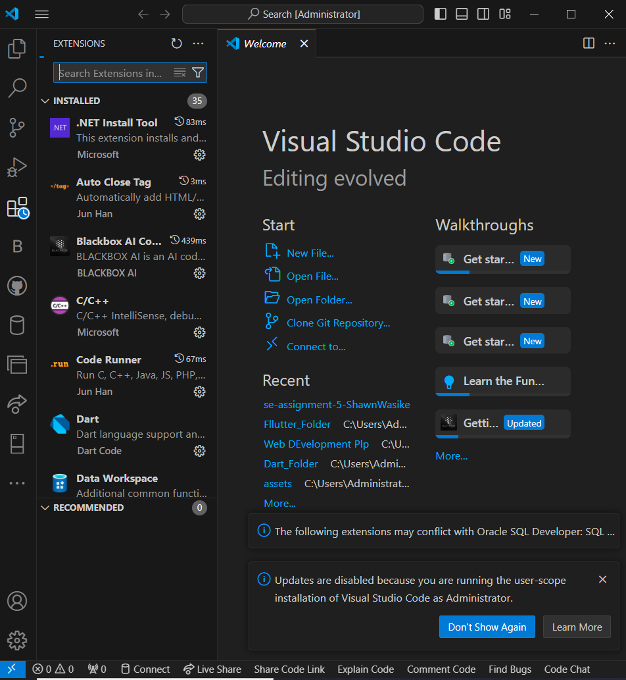

3. Search for and install the following recommended extensions and others according to there importance in your project or work:

- Python – To build python projects.

- Git Lens — Git supercharged

- Auto close tag – To assist aby auto closing your tags.

- Live Server - To enable live changes on the created website without saving the file.

- Prettier - Code formatter.

And so on.

